**MUHAMMAD S/O FURQAN**

**PROJECT NAME:**

CONVERTING DECIMAL NUMBERS TO OCTAL NUMBERS.

DESCRIPTION:

This program will convert decimal numbers into octal numbers.

If you enter any decimal number it will give output in octal numbers.

**Input Program:**

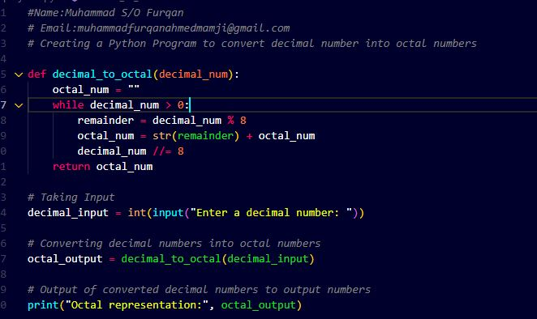

**Output program:**

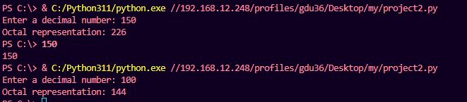

**GITHUB LINK:**

**https://github.com/binfurqann/Python-project2/upload**